CASE 1  
There is a start state where the task difficulty can be checked at a cost. If checked, there are probabilistic transitions to easy or hard states where there are different amounts of effort required to finish the task. There is an option to shirk in each of the states.

Parameters:

Efforts(check, work_easy, work_hard) = -0.1, -0.2, -1.0 Rewards(pass, uncompleted, fail, shirk) = 4.0, 0.0, -4.0, 0.5 Efficacy = 0.5;   
probability of transitions to easy and hard on checking = (0.9, 0.1)

Without discounting, there are no delays in checking or working (abandon if costs are prohibitive). With discounting (γ =0.9), there are delays in checking and working. In this regime, checking on timestep 6 and an unlikely transition to hard state means to delay working further until timestep 9. This seems like a planned ‘defection’ in case the task is ‘unexpectedly’ tough.

γ =1:

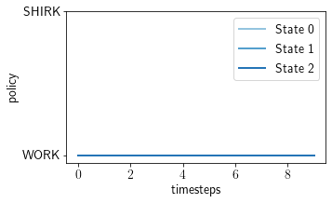

γ =0.9

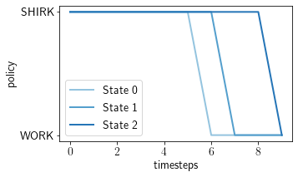

Varying the probability of task being tough: Higher this probability, the better it is to check the task later. So, if it is likely that the task is tough, then simply start late which might eliminate a defection.

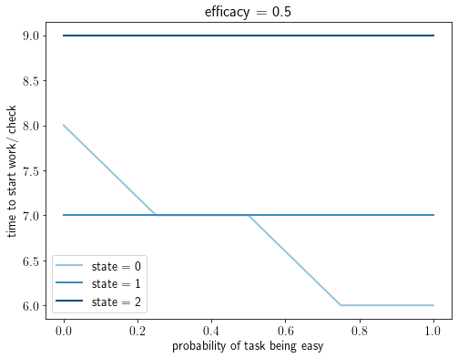

Case 2

There are multiple possible effort states with each requiring a different amount of effort to finish the task. Independent of the actions taken, there are transitions between these states. As before, there are actions to work or shirk, delayed reward/ punishment on passing/ failing and an immediate reward for shirking in all the states.

Parameters

Efforts(easy, medium, hard) = -0.2, -0.5, -1.0  
Discount factor = 1   
transition dynamics between states (cyclic):

|  |  |  |  |
| --- | --- | --- | --- |
| **P(s_t,s_t+1)** | **easy** | **med.** | **hard** |
| easy | 0.2 | 0.6 | 0.2 |
| med. | 0.2 | 0.2 | 0.6 |
| hard | 0.6 | 0.2 | 0.2 |

Even without discounting, it is optimal to delay in the medium and hard states in the hopes that the easy state will be reached. How long the task is delayed depends on the efficacy.

Efficacy = 0.7

Efficacy = 1.0

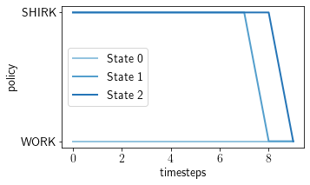 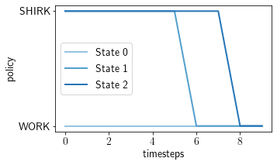

I think this is already a non-committing type of procrastination. The agent doesn’t know when to work because when the easy state will be reached is unknown. However, there is a commitment to the latest possible time that the agent will wait for this better state to come along.

Case 3

Consider a case where the states of completion are not fully observable. Further, it is only possible to finish by submitting. However, submitting an incomplete assignment has consequences. Hence, submission is procrastinated because the agent must wait for more info to be sure about the state before submitting. This would be non-committing because it is unknown when enough information will be accumulated.